**Project Management**

Communication:

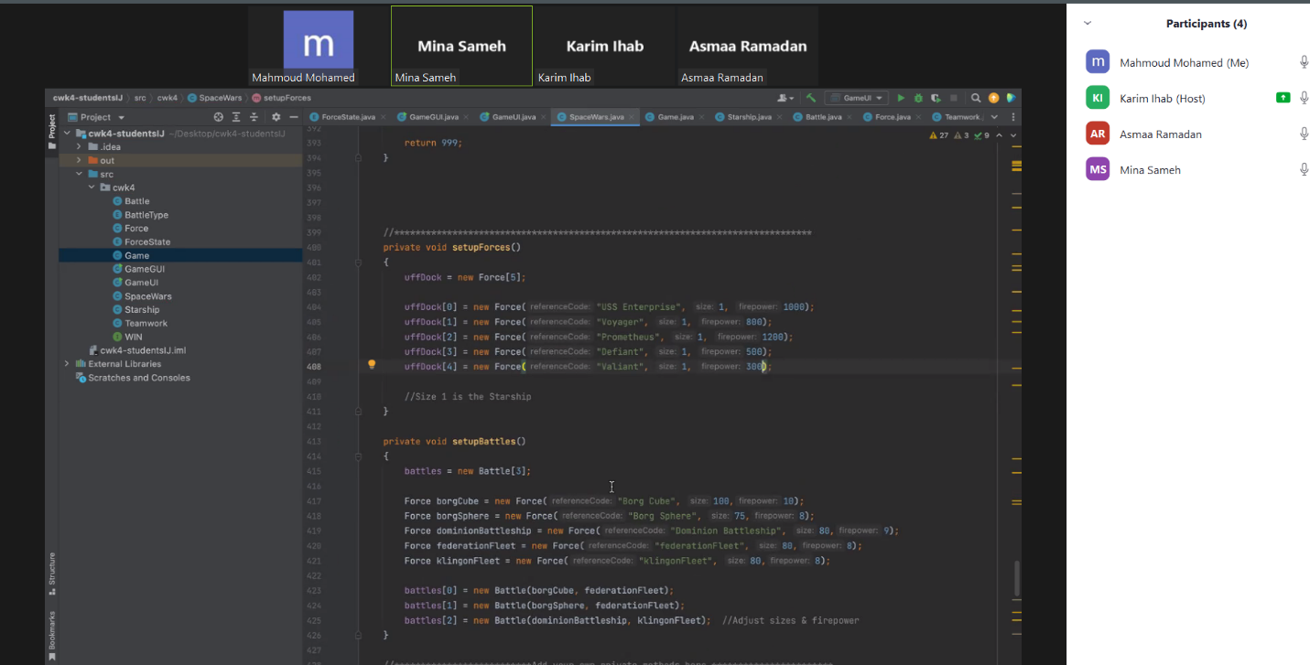

Kanban:

29/3/2023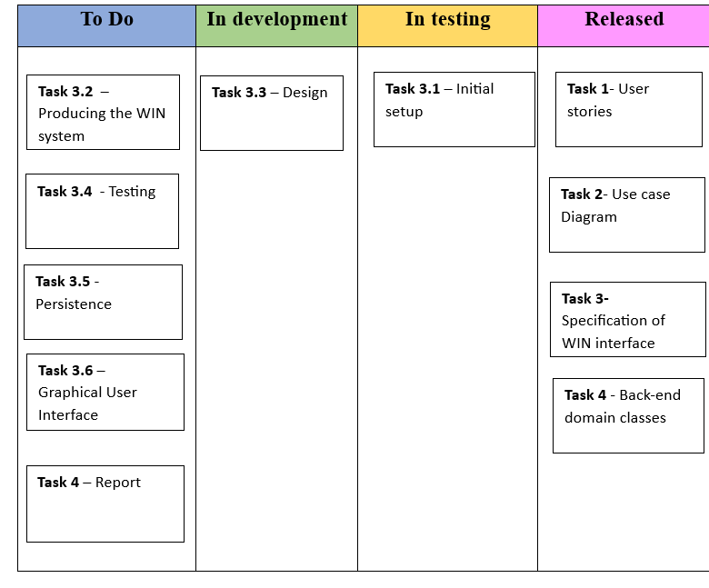

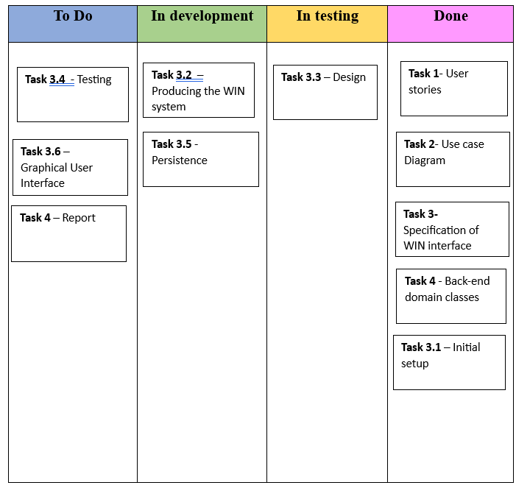5/4/2022

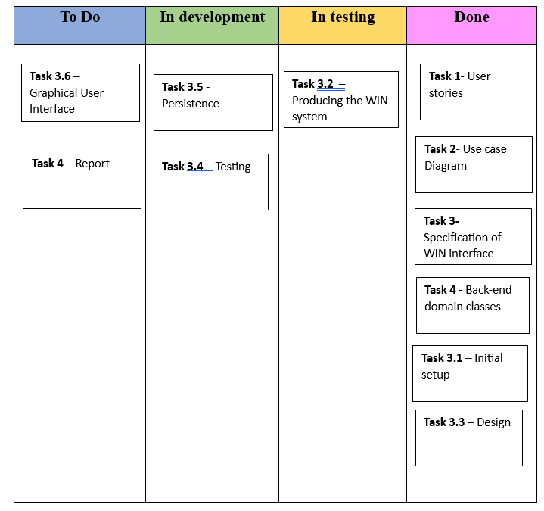10/4/2023

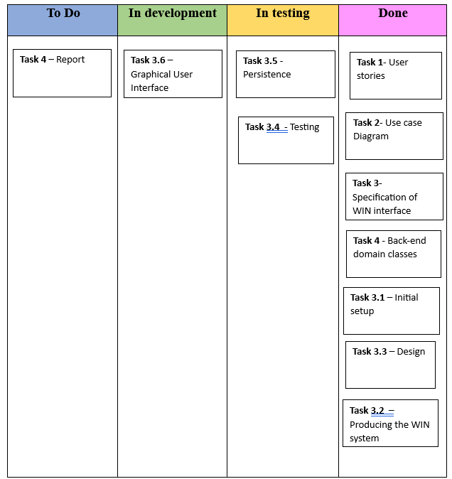18/4/2023

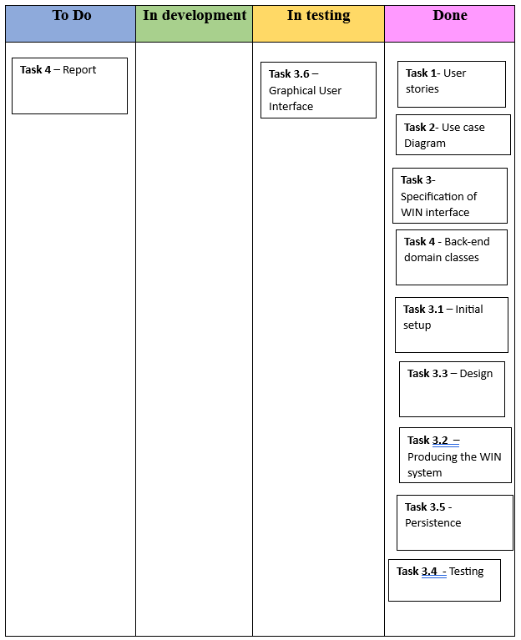22/4/2023

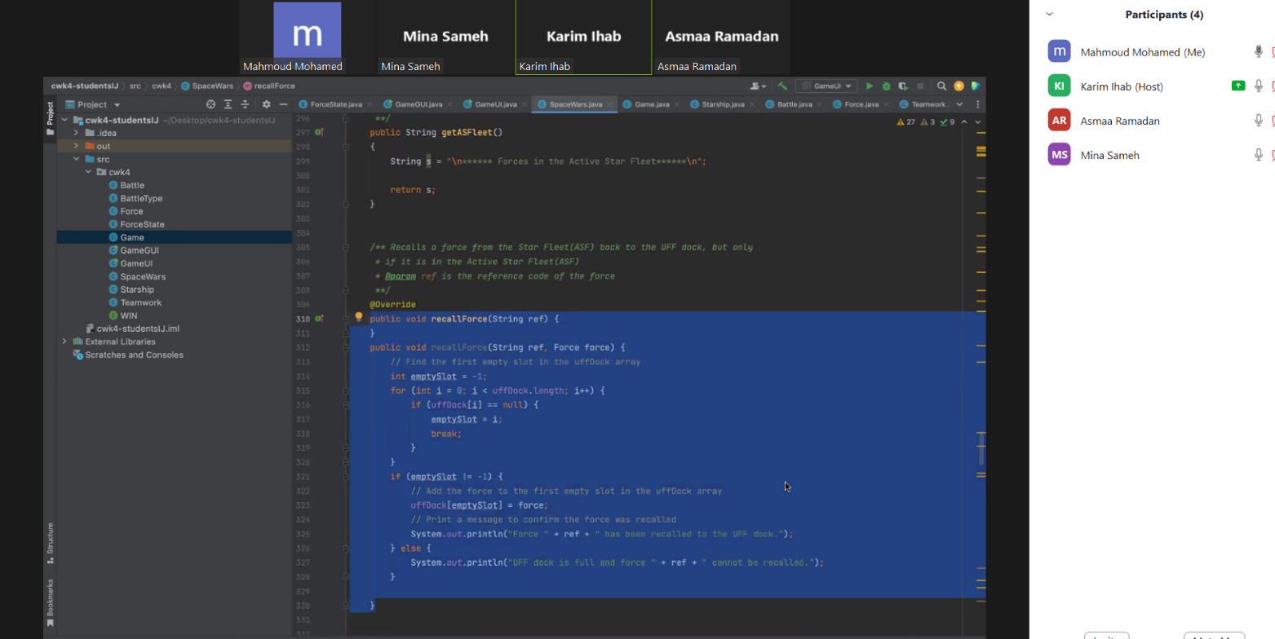Version Control – Repository

